Music in Healthcare Settings Apprenticeships
Sept 2017 - June/July 2018

APPLICATION FORM
Name:
Address:
Phone number:
Mobile number:
Email address:
Instrument(s)/Voice:

Please give us details of your interest and experience in Music in Healthcare settings practice:

How would this apprenticeship inform your future practice in the music in healthcare settings sector?

Please describe any experience you have in instigating your own professional programmes of work and/or any plans you might have for future programmes:

Is there anything else we should know/you wish to tell us?

Are you willing and able to commit to the full programme of the apprenticeship as detailed on the Music in Healthcare Settings Apprenticeship brief? This includes all development, mentored practice, peer mentoring and conference days.

If shortlisted, are you available to attend an interview/audition in Derby on Thursday 29th June 2017?

Please send your completed application (to reach us by midday on Thursday 8th June 2017) to:
apprenticeships@opusmusic.org
or
OPUS Music CIC, 3 Dodgewell Close, Blackwell, Alfreton, Derbyshire, DE55 5BH

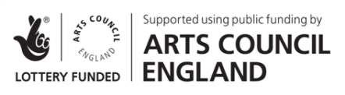
Supported using public funding by the National Lottery through Arts Council England

